**LAB REPORT # 04**



**Spring 2020**

**CSE 203L Electric Circuit Lab**

Submitted by: **SHAH RAZA**

Registration No. : **18PWCSE1658**

Class Section: **B**

“On my honor, as student of University of Engineering and Technology, I have neither given nor received unauthorized assistance on this academic work.”

Student Signature: ______________

Submitted to:

**Engr. Abdullah Hamid**

June 19, 2020

Department of Computer Systems Engineering

University of Engineering and Technology, Peshawar

**Objectives of Lab**

To calculate, compare, draw, and measure the characteristics of a silicon and germanium diode.

**Series and parallel Diode**

Diodes are connected inside the circuit in two configurations. These configurations are:

* Series configuration
* Parallel configuration

Both of the connection patterns are widely used

**Series Configuration**

Series connection means a side by side connection. When two components are connected in series, they have one common junction.When connected in series, we observe the following properties to hold true among the diodes:

* Resultant diode’s forward voltage increases
* Reverse blocking capabilities of diodes are increased in series connection

**Parallel configuration**

Parallel connection means the components are connected across each other, having two common points. Current differs across each component while voltage drop is the same. When diodes are connected in parallel, this same trend is observe

* Current carrying capacity increases
* No conduction in resultant diode in both sides

**Apparatus Used**

* DMM (Digital MultiMeter)
* DC Power Supply
* Resistor 2.2 kΩ
* Diode:

Silicon (1N4002)

Germanium (1N4001)

**Procedure**

* Series Si-Si Diode Configuration
  + Determine the current ID,VD, Vo for the network
* Parallel Different Diode Configuration
  + Determine the voltage Vo for the network

**Diode in Series**

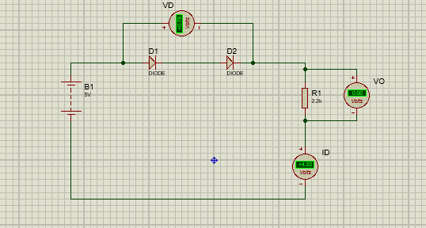

**ID=4.22V**

**VO=0V**

**VD=0.78V**

**PCB layout**

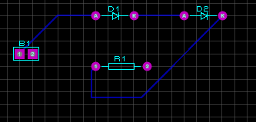

**Diode in Parallel**

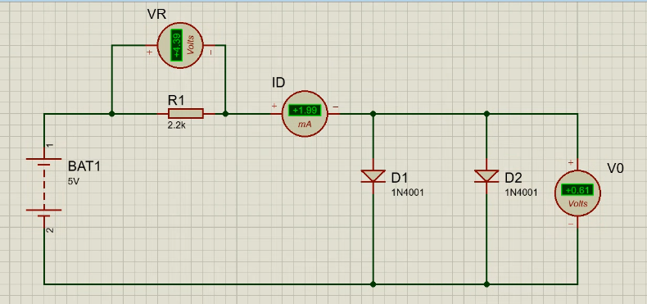

**VR=4.39V**

**ID=1.99mA**

**VO=0.61V**

**PCB layout**

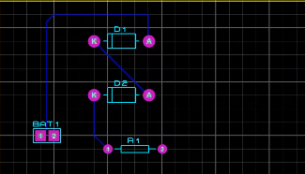

**Analysis**

These two simple examples based on very common components can help the students to appreciate the notion of validity of approximate expressions: it may help them notice that for components having nonlinear behavior, the results are strongly dependent on the type of combination.